Computer Games Programming
Tutorial 01 - Installing and Configuring SDL 2. Display and Keyboard Setup

Introduction

In order to display 2D graphics for this unit you will need to be able to use SDL version 2. SDL is a cross platform game development library that handles common, low-level tasks such as creating windows, accepting user input, loading and drawing images, and many others. This tutorial will take you through the steps to set up a default SDL 2 Visual Studio project that will be used for subsequent tutorial exercises. Additionally the tutorial shows you how to correctly set up SDL 2 to display graphics, and guides you through the process of responding to keyboard events.

Installing SDL 2

There is no real installation needed for SDL 2, all you need are the SDL header and library files in the directory with your projects. It's important you put the files in the correct place, and that you also create the Visual Studio projects in the correct way - the projects will be set up to expect the SDL directories to be in a specific relative path.
- SDL: https://www.libsdl.org/download-2.0.php
  - Download the development libraries
  - (SDL2-devel-2.0.X-VC.zip)

NOTE - If, because of the Visual Studio U: drive incompatibility, you are developing your projects on desktop or memory stick you will need to copy the SDL folder to that location. Also you will need to have a copy in the correct location when working from home.

Creating a default Visual Studio 2013 (VS2013) SDL 2 Project
SDL 2 requires various settings and configuration changes to be made to a project. In this section you will create a default project template that you can use for all future projects that use SDL 2 to avoid having to manually configure the project settings for every exercise.
- Open VS2013 and select File→New→Project from the menu bar. The New Project dialog will appear:
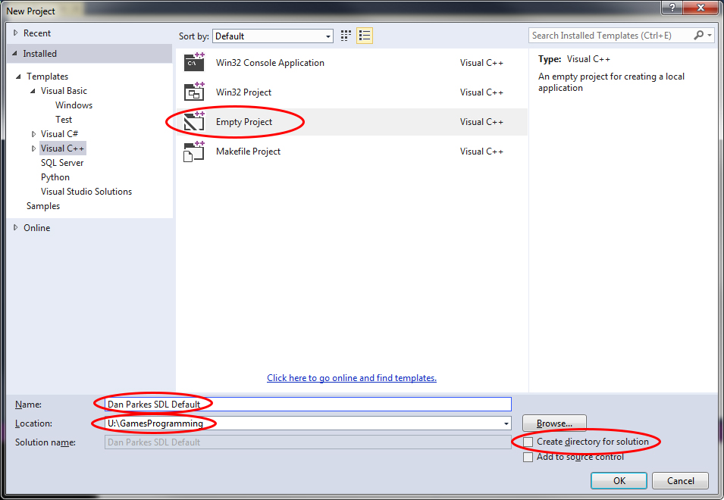
- From the list click on Empty project. In the name field type in name of the project using your name - e.g. Dan Parkes SDL Default.
- In the Location field type in U:\CGP.
- Ensure Create directory for solution is NOT ticked (THIS IS IMPORTANT as if it is ticked the project will be created in the wrong directory, and will not be able to find the SDL files).
- Press OK and your project will be created.
- Finally add a main.cpp to the project, just leave it empty for now (DO NOT miss this step, it reveals certain options in the project that need to change)

Configuring the Default Project to use SDL 2

You have now created your default project, but you will need to set it up to enable it to use SDL 2.

Step 1 - Set up Directory Paths and Defines for All Configurations
- If you cannot see the solution explorer tab, select View→Solution Explorer.
- If it is not already highlighted, click on the project (NOT on the solution), see below:
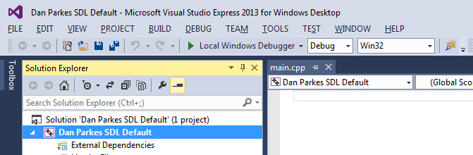

- Select Project→Properties (or press Alt-F7). A property pages dialog box similar to this will appear:
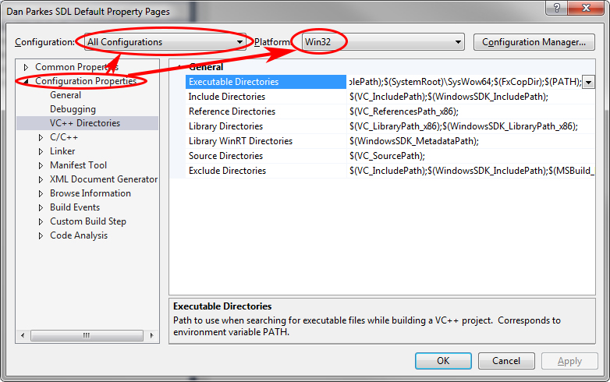

- In the left panel select Configuration Properties. If the submenus are not visible, click on the + to show them.
- Ensure the Configuration selector is set to All Configurations, and Platform is set to Win32.
- Next, select VC++ Directories→Include Directories. At the right side of the list of include directories there is a down arrow, click on this to show the <Edit...> control, as shown below:
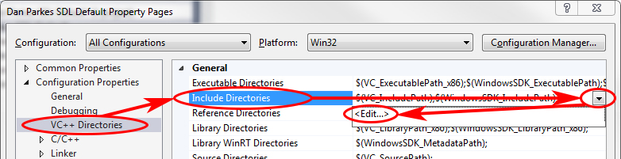

- Select <Edit...> to bring up the Include Directories dialog:
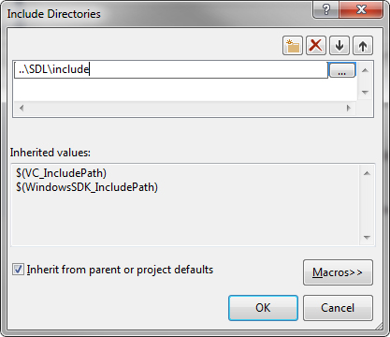

- Double click at the top of the white box, click the button with the 3 dots and Navigate to the SDL folder, select the includes folder and press “select folder”.
- Select Library Directories, and follow the same procedure as before, EXCEPT, this time you are navigating to your SDL folder\lib\x86 and press “select folder’.
FYI –Both 32-bit and 64-bit versions of the SDL libraries are provided. Usually, the version you use will depend upon the operating system you are building your application for. 64-bit libraries offer better memory management for very large projects, but obviously won’t work on a 32-bit operating system.

We are going to build relatively small games, so we’ll go for the 32-bit libraries to ensure maximum operating system compatibility – and avoid having to reconfigure our projects if we start development on a 64-bit machine (e.g. the uni machines) and continue on a 32-bit machine (e.g. your home PC).
- Click on Apply to save the changes. Don't press OK just yet, there are more configuration settings to be done.

Step 2 - Add Library files
- Make sure the Configuration at the top is set to All Configurations
- Navigate to Configuration Properties→Linker→Input
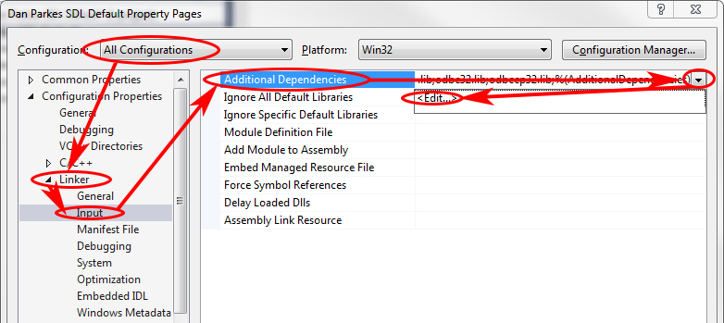

- Click on Additional Dependencies - it will highlight and display a down arrow
- Click on the down arrow - Edit should appear
- Click on Edit - the Additional Dependencies dialog should appear.
- In the top half of this dialog copy or type in:
SDL2.lib
SDL2main.lib

Your dialog box should look like this:
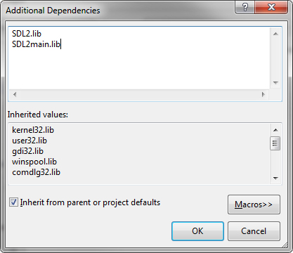

If it does, press OK.

Step 3 – Configure the project as a console application

FYI –SDL does some behind-the-scenes stuff to intercept the entry point function into the application (e.g. the main() function) based on the application’s subsystem type. We also need access to the entry point function too to write our program, and in order to get access to it we have to specify the application subsystem so SDL can set itself up correctly.

We have a few choices of subsystem type – each of which may have different entry point function names and parameters - but we’re going to keep things familiar and simple. We’ve gone for a console application which means our entry point will be the familiar main() function.

- Make sure the Configuration at the top is set to All Configurations
- Navigate to Configuration Properties→Linker→System
- Click on SubSystem- it will highlight and display a down arrow.
- Click on the down arrow, and from the drop-down list that appears, select Console (/SUBSYSTEM:CONSOLE)
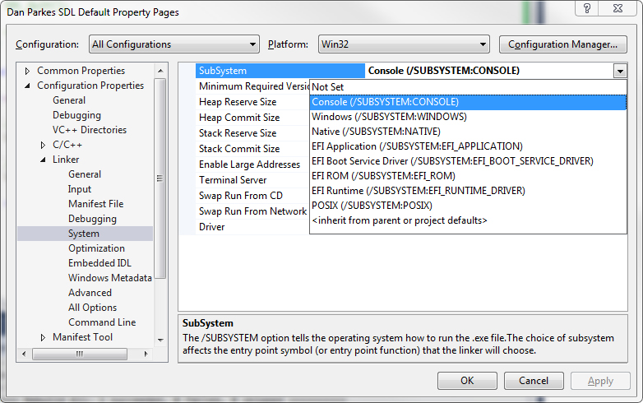
- Click Apply.

Step 6 - Copy the runtime DLL into project folder

The final step is to copy the required runtime DLLs into the project folder.
- Navigate to the SDL\x86\lib directory
- Copy the following file
SDL2.dll
- Navigate to the default SDL project folder you created, and paste the file:

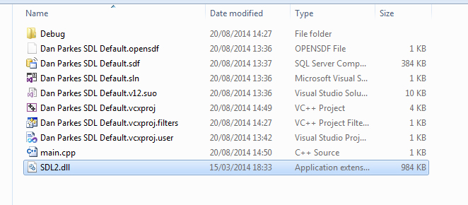

You need to ensure a copy of the dll file is in this location for every project so they can be found when running the program in the IDE. If you want to run directly from the exe file you will also need to copy the dll to the exe directory.

You now have a fully configured project template file that can be used as a basis for most future SDL 2 projects.

NOTE - never use this project template directly, always copy and create a new version as detailed in Guide 01a

Exercise 01 - Testing SDL project configuration

In this exercise you will create a new project based on the default SDL project, and test that it works correctly.

- Follow the previous instructions in order to create a default SDL 2 project.
- Create a project called [your name] Tutorial 03 Exercise 01 based on your SDL default project.
REMEMBER - use a COPY of the default project, correctly renamed. Follow the instructions in Guide 01a on creating a new project from and existing one.
- Open the new project.
- Type the following code into main.cpp:
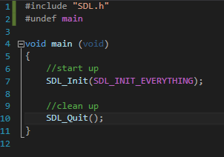
- Build and run the app in both Debug and Release mode (the selection list for these are in the VS2015 toolbar).
If you have correctly followed the instructions both versions should build and run with no compile errors, and the program should exit with return code 0 (see Output window). If not carefully retrace your steps to try to find the problem. If you cannot identify the problem in less than 30 minutes it may be best to start again and follow the instructions very closely indeed.

Introduction to RGB colour

Before starting to use SDL, you need to understand the RGB colour model. In computer graphics, every colour is considered to be composed of mixtures of the three primary colours, red, green and blue. For example, yellow is an equal mix of red and green; magenta is an equal mix of red and blue, and white is an equal mix of all three.

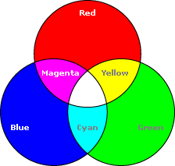

The red, green and blue components can also vary in intensity. Intensity is a measure of how much of that primary colour is included in the final colour, and is represented as a whole number between 0 and 255. Black is regarded as the absence of all three colour components, whilst white is a mix of all three at full intensity. So pure red at full intensity would have a red component of 255, a green component of 0, and a blue component of 0. Similarly yellow at full intensity would be red 255, green 255 and blue 0. Red at half intensity (i.e. a dim red) would be red 128, green 0 and blue 0.

Here's a representation of the relationship and graduation between the colour components mapped onto a cube, with 255 representing full intensity for each component:

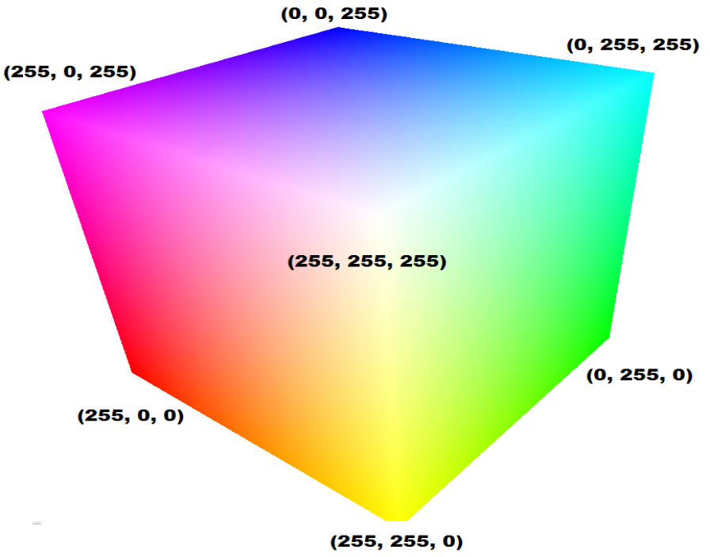

Exercise 02a - Creating a colourful display

This exercise will show you how to create the SDL 2 display screen, and asks you to change the colour of that screen using RGB colours.
- Create a new project called [your name] Tutorial 03 Exercise 02 based on your SDL default project.
- In this project, add a header file named Game.h and a source file named Game.cpp. Don’t forget to add some description headers to each file.
- In the Game.h file, add the following:
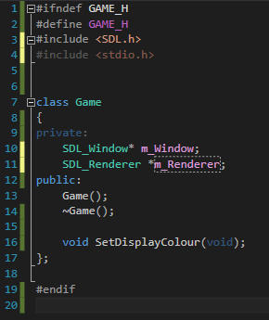
FYI – Note the forward declarations of a couple of structs at the top of the header file, which are then used declaring pointers in the Game class declaration.

Forward declaring SDL_Window means we are telling the compiler that at some point there will be a struct named SDL_Window defined, and that’s what we’ll be using for the m_window pointer when we start using it. The idea behind it is exactly the same as forward declaring functions at the top of a source file.

Why do this? Forward declaring structs and classes means we don’t need to include those structs and classes’ header files. By stripping out unnecessary includes we can minimise compile times and circular dependencies and improve performance.

- In Game.cpp, create a constructor for the Game class. In here, we are going to set up everything we need for SDL to display something on screen. Add the following to your constructor:
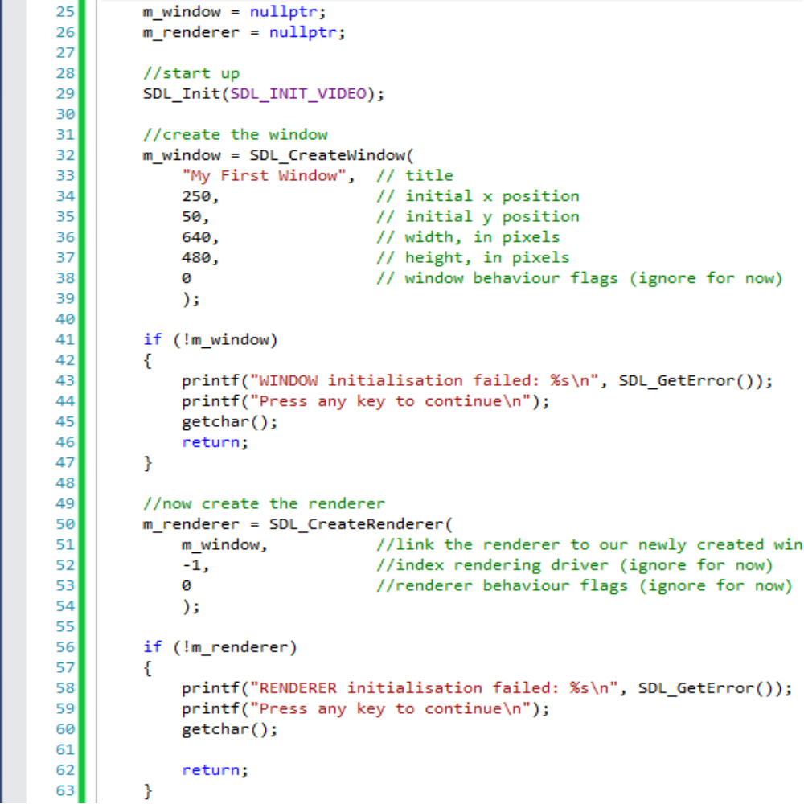

- Now we need a destructor to clean up the initialisation. Make a destructor for the Game class and add the following code:
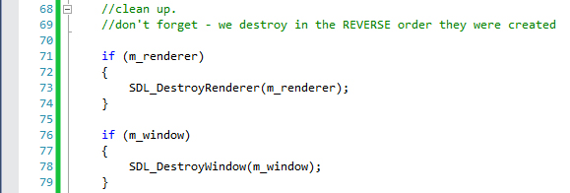

- Great, we’ve got the housekeeping done … but the code doesn’t actually do anything yet. Let’s get on with setting the background colour and displaying it on screen.
The Game class’ header file has declared a method named SetDisplayColour(). Add the matching definition for SetDisplayColour() in Game.cpp, and for the method body, add the following code:

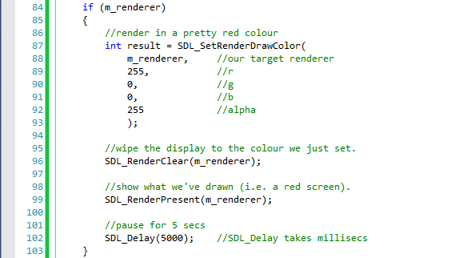

Most of the code so far code has been self-explanatory, but SDL_RenderPresent()needs more explanation. SDL creates two image buffers in the renderer’s create function, the one being displayed on the screen, and hidden one called the back buffer that is currently being drawn on. SDL_RenderPresent() swaps these two buffers – the back buffer becomes the display buffer and vice versa. If SDL_RenderPresent()isn't called, the buffers are never swapped and what you draw will never be displayed. Don't worry if this doesn't make sense just yet it will be discussed in more detail later in the unit, just use it as shown.

- Our Game class is finally set up but we need to create a game object and call our new SetDisplayColour() method to see anything happening. Go back to main.cpp, delete everything but your file description header and add the following:
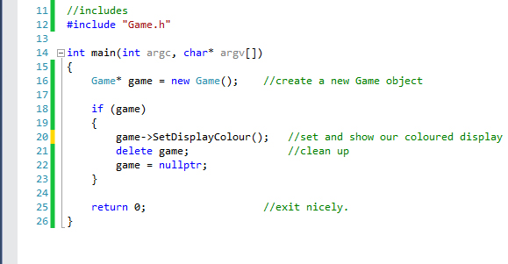

- That’s it! Build and run it. Then, adjust the colours in the SetDisplayColour() method, find one that you like and keep a note of it.

Exercise 02b – Improving your code
The SetDisplayColour() method seems to be doing too much for the task it’s named for – the Game class could be improved by extracting some of the code from SetDisplayColour() and putting it into new, sensibly named methods.
Design in your logbook the new methods you would implement.
Once designed, implement your new methods, make sure everything is called in the right order in main() and most importantly check that your application still does exactly what it used to do.

Exercise 02c– Modifying your display
Add a loop (or loops) that gradually changes the screen colour. Discuss in your logbook and in comments which methods need to be in the loop, and why.

Events and Keyboard input in SDL 2

SDL 2 uses an event-driven architecture for handling actions and occurrences that can be handled by your application. Events tell you that something has happened in your program such as a key press, mouse movement and clicks and display changes amongst others. SDL 2 uses them to notify you that something has happened that you might want to respond to in your program.

Using an event queue system is an efficient way to handle events; you can wait for the arrival of new events and handle them when they occur. The event system reduces processor usage compared to the alternative of repeatedly checking, called polling.

SDL 2 uses event sources, which is something that tells the program when something has occurred. There are several standard SDL event sources, such as keyboard, mouse and display.

Event sources place their events in an event queue in a first-in-first-out fashion, and are removed when the events are handled by the main program.

Exercise 03 - Responding to the keyboard

The most obvious and immediately useful event that you might want to respond to is key presses. However, the process of doing this is quite long winded, so the easiest way to demonstrate how it works is via an example.
- Create a project called [your name] Tutorial 03 Exercise 03 based on your Tutorial 03 Exercise 02 project.
- Create and add 2 new files to your project - input.cpp and input.h - which we’ll use for a new Input class. Make sure the new files are in the Source and Header filters respectively in your project – if they’re not, just drag and drop them into the correct filters.
- In input.h, add the following code:
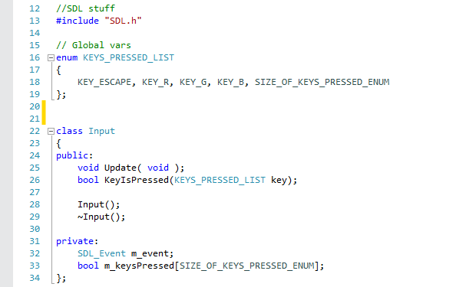
- In input.cpp, define constructor and destructor methods for the Input class.
- Also define Update and KeyIsPressed methods, using the declarations in input.h as reference for the parameter lists and return values for each method.
- Copy the following into your newly defined Update method:
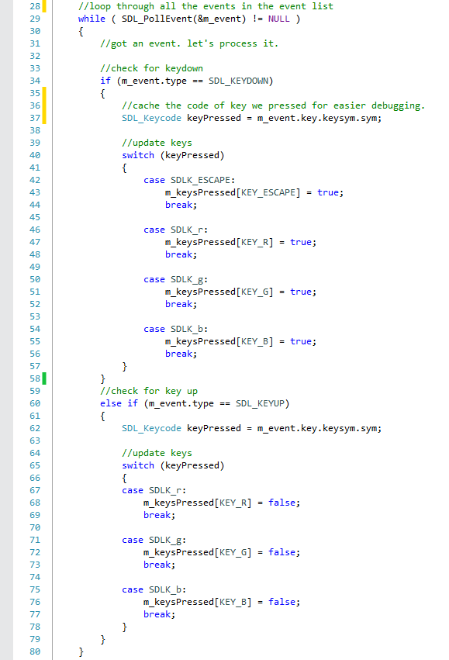
- Fill out your KeyIsPressed method. This method should use the key variable given to it via the parameter list as an index into the m_keysPressed member array, and return the value stored in that array index.
- You should also make sure your m_keysPressed array is initialised to null when a new Input object is created. Decide how you’re going to do that and the best place in your code in which to do that is … and then do it.
- Now you’ve set your new input class up, it’s time to use it. Replace the code in your main.cpp file (including #include statements) with the following code: 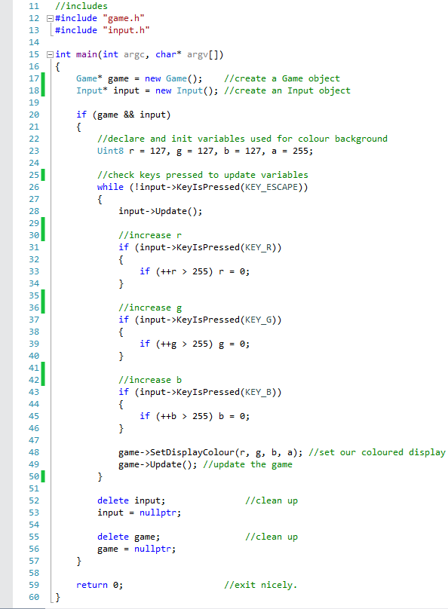
- Build and run the program to ensure it works. You should be able to adjust the background colour by pressing r, g and b on the keyboard.
- Once you understand how this code works (see below) add at least 3 more keys that are handled in order to reduce the rgb values as well as increasing them.

Explaining the code

Let’s talk about some of the code you’ve just written.

Enums make a return from last year’s Programming Fundamentals unit:



To recap, an enumeration (enum)is a list of user defined elements that are assigned integer values, by default starting at 0 and incrementing by 1 for each element. So above KEY_ESCAPE has the value 0, KEY_R is 1, etc.

An enumeration is being used here as a convenient way to name each element in the keys_pressed[] array. The enumeration contains all the keys you want to deal with in the program, if you need more keys you should add them here. SIZE_OF_KEYS_PRESSED_ENUM must be last, as it is used to ensure the keys_pressed[] array is always large enough to contain all the key presses required. The keys_pressed[] array stores a boolean value that lets you know if a key is pressed and held down. This array is updated in the Input::Update() function.



As mentioned at the start of this section, SDL uses events to inform of occurrences that you might want to respond to in your code.

SDL_PollEvent() will pop the event off the end of the event queue and store it in an event pointer that you provide. You can then access the contents of that event pointer and decide if you want to respond to it.

NOTE: calling SDL_PollEvent() while there are events on the queue will remove the first event from the queue. That means you have to deal with that event there and then – polling the queue again this tick will NOT return that event again as it has already been consumed.

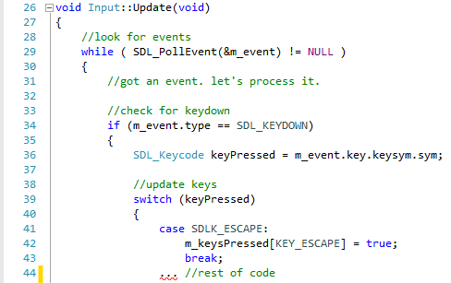

The Update() function in the Input class shows one way events can be processed. An event is taken from the queue, and if it's an SDL_KEYDOWN event type it checks which key. If it's one of the keys we are looking for the appropriate keys_pressed[] index is updated. This is the array used in the game loop to check for key presses. If you want to respond to other types of event, then this is the place to handle them, for instance if you add mouse input. Other methods for processing events will be investigated later in the unit.

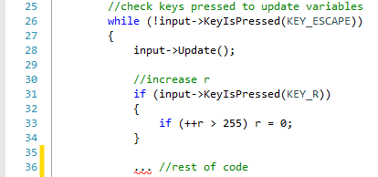

This section of code in the main()function shows how the keys_pressed[] array is used to run the game loop until escape is pressed, and also to respond to a key press to update the game state, in this case the r key updates the red value.

